Configuration of web Apache server
To install the package #rpm -qa httpd*
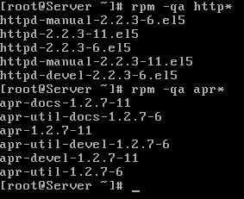
To check the ip
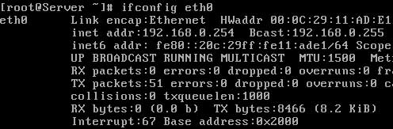
To start the http daemon verify
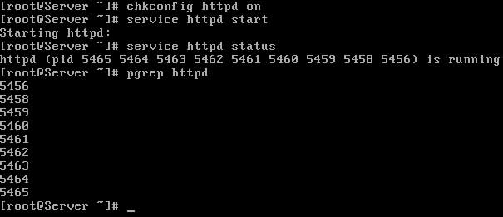
To config to virtual hosting (In this example we will host a website www.vinatha.com create a doc root dir.
for testing purpose we are writing site name in its index page :wq
now open /etc/hosts file

in the end of file bind system ip with www.vinita.com
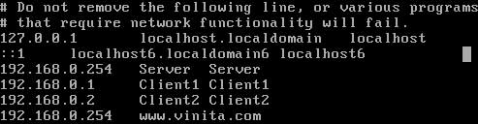
now open /etc/httpd/conf/httpd.conf main configuration file of apache server
remove # from the beginning and add the IP of host & Now go in the end of file and copy last seven line [ virtual host tag ] and paste them in the end of file. change these seven lines as shown in image
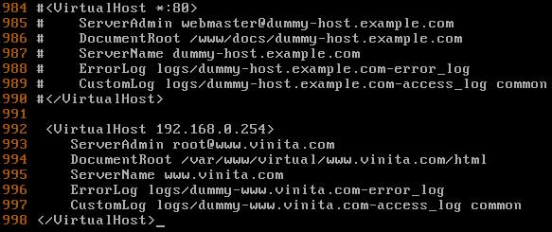
now save this file and exit from it
now restart the httpd service
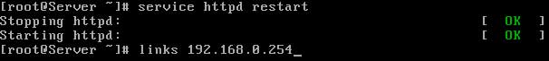
if linkscommand retrieve yourhome page

